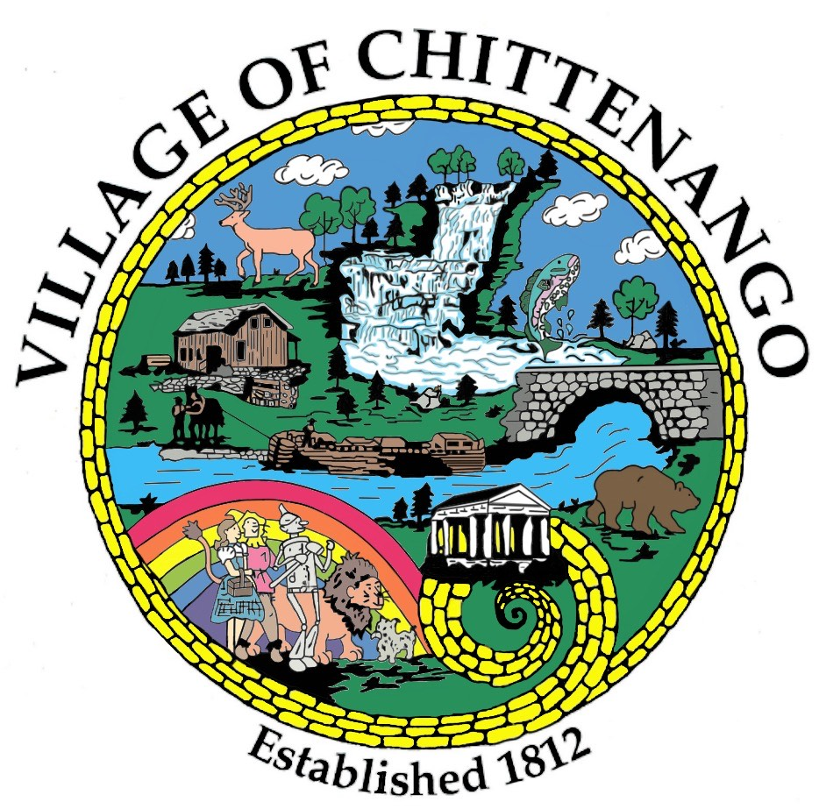 | VILLAGE OF CHITTENANGO  “where the water runs north”  222 GENESEE STREET  CHITTENANGO, NEW YORK 13037  PHONE: (315) 687-3936 FAX: (315)687-6622  www.chittenango.org  ______________________________________________________________________________

PLANNING & ZONING BOARD AGENDA
July 7, 2025

Call regular meeting to order

Minutes: June 2, 2025

Old Business:

Community Bank Signage revision of proposal for Compliance with the Village of Chittenango Comprehensive Plan.

New Business:

Next Meeting: Monday, August 4, 2025 @ 7:00 PM

Adjourn

