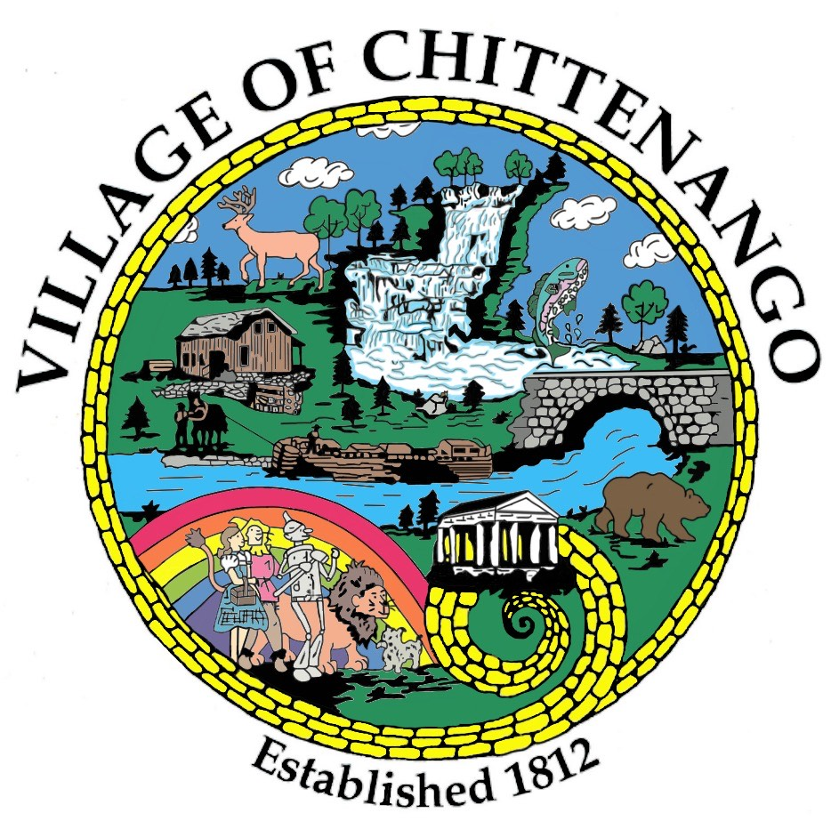 | VILLAGE OF CHITTENANGO  “where the water runs north”  222 GENESEE STREET  CHITTENANGO, NEW YORK 13037  PHONE: (315) 687-3936 FAX: (315)687-6622  www.chittenango.org  ______________________________________________________________________________

PLANNING & ZONING BOARD AGENDA
August 4, 2025

Call regular meeting to order

Minutes: July 7, 2025 with addendum

Old Business:

Community Bank Signage revision of proposal for Compliance with the Village of Chittenango Comprehensive Plan.

New Business:

202 Tuscarora Road Puma Accounting new signage

211 Juneway Drive area variance for 2 sheds

131 W Genesee Street area variance for shed

254 Genesee Street special permit

Next Meeting: Monday, September 8, 2025 @ 7:00 PM (due to Labor Day September 1).

Adjourn

